Advanced SQL Exercises
Exercise 1: Ranking and Window Functions
Goal: Use ROW_NUMBER(), RANK(), DENSE_RANK(), OVER(), and PARTITION BY.
Scenario:
Find the top 3 most expensive products in each category using different ranking functions.
Steps:
- Use ROW_NUMBER() to assign a unique rank within each category.
- Use RANK() and DENSE_RANK() to compare how ties are handled.
- Use PARTITION BY Category and ORDER BY Price DESC.

CREATE DATABASE CompanyDB;
USE CompanyDB;
CREATE TABLE Products
(
ProductID INT PRIMARY KEY,
ProductName VARCHAR(50),
Category VARCHAR(30),
Price DECIMAL(10,2)
);
INSERT INTO Products VALUES
(1,'Laptop A','Laptop',60000),
(2,'Laptop B','Laptop',75000),
(3,'Laptop C','Laptop',75000),
(4,'Laptop D','Laptop',50000),

(5,'Phone A','Phone',30000),
(6,'Phone B','Phone',45000),
(7,'Phone C','Phone',45000),
(8,'Phone D','Phone',25000),

(9,'TV A','Television',70000),
(10,'TV B','Television',90000),
(11,'TV C','Television',90000),
(12,'TV D','Television',65000);
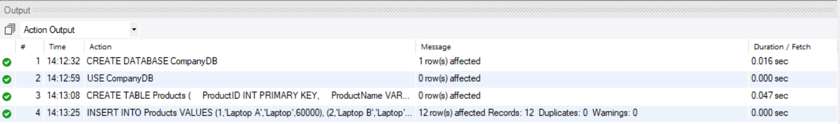
SELECT * FROM Products;
SELECT
ProductID,
ProductName,
Category,
Price,
ROW_NUMBER() OVER (
PARTITION BY Category
ORDER BY Price DESC
) AS RowNum
FROM Products;
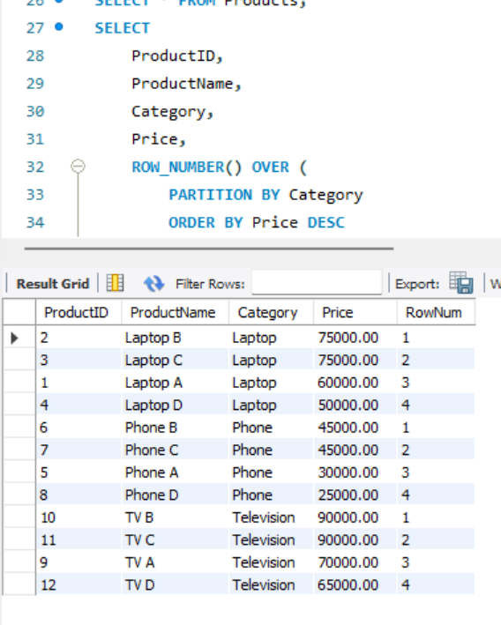

SELECT
ProductID,
ProductName,
Category,
Price,
RANK() OVER (
PARTITION BY Category
ORDER BY Price DESC
) AS RankNum
FROM Products;
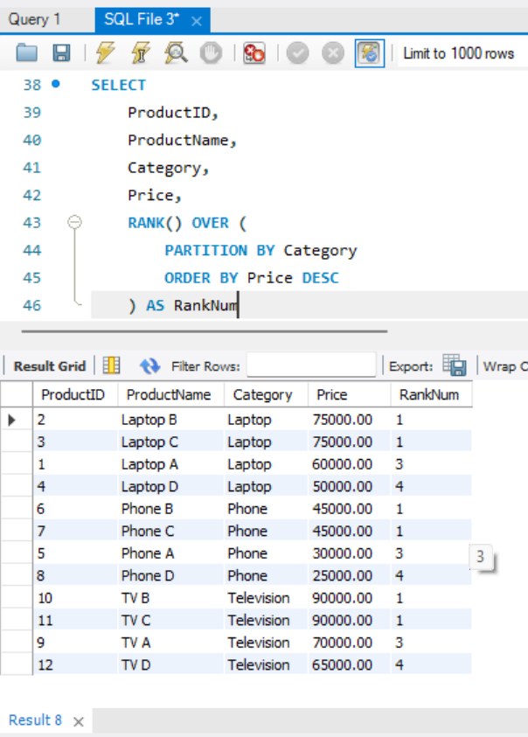

SELECT
ProductID,
ProductName,
Category,
Price,
DENSE_RANK() OVER (
PARTITION BY Category
ORDER BY Price DESC
) AS DenseRank
FROM Products;
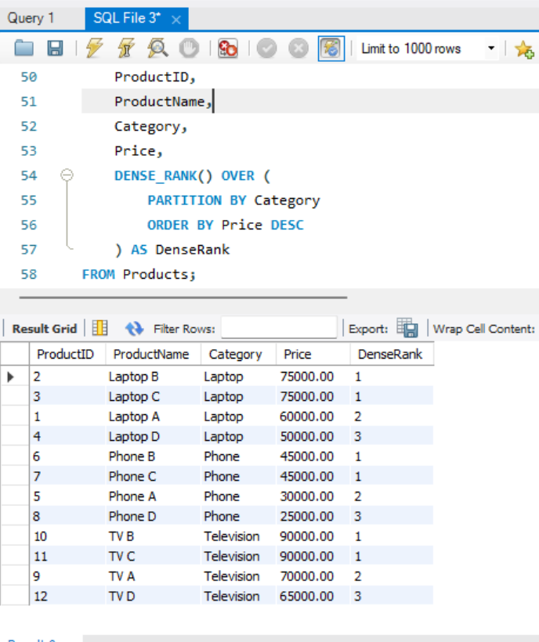
SELECT *
FROM (
SELECT
ProductID,
ProductName,
Category,
Price,
ROW_NUMBER() OVER (
PARTITION BY Category
ORDER BY Price DESC
) AS RowNum
FROM Products
) AS RankedProducts
WHERE RowNum <= 3;
